**Paper Title**

**Author1, Author2, Author3  
 1,2,3Department of Electrical Engineering  
 1,2,3University of Dar es Salaam, Tanzania**

***Abstract- Induction motors and gearboxes are critical components in modern industries, serving as essential tools for the operation of numerous machines. This study presents a diagnostic approach for identifying various faults in an electromechanical system using infrared thermography and a convolutional neural network (CNN).***

***Keywords: thermography, convolutional neural networks, induction motor faults, gearbox wear***

**1. Introduction**

Electromechanical systems, consisting of both mechanical and electrical components, are essential in various modern industries. Their applications span across sectors such as manufacturing, the electrical industry, process automation, and the automotive industry, among others [1,2]. These systems integrate components like pulleys, belts, shafts, and mechanical couplings, all of which contribute to their functional versatility. However, induction motors (IMs) and gearboxes (GBs) are the most prominent components in industrial electromechanical systems due to their unique ability to convert electrical energy into mechanical energy while managing torque transmission efficiently [3].

**2. Proposed Methodology**

The proposed methodology for detecting multiple mechanical faults in induction motors (IM) and gearboxes (GB) is depicted in Figure 1. This approach consists of five interconnected stages aimed at ensuring precise and robust fault diagnosis. The process begins with the creation of a thermographic image database generated through physical experiments. These images serve as the foundation for subsequent analysis. In the second stage, the thermographic images are cropped to isolate specific regions of interest, such as the gearbox, coupling, and induction motor, while disregarding extraneous elements like the background or unrelated components. This refinement focuses the analysis on critical areas of the system. The third stage involves data augmentation to enhance the diversity and size of the image dataset. Techniques like horizontal flipping and intensity variations are applied to improve the

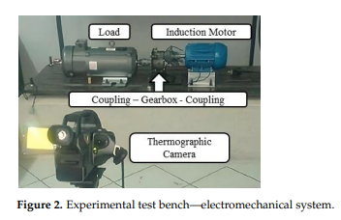

To ensure the accuracy of environmental conditions during data acquisition, a Fluke 975 air quality meter was employed to monitor the testing environment. Furthermore, an emissivity value of 0.95 was used to optimize the precision of temperature readings in the captured thermographic images. This systematic and controlled approach to image acquisition forms a foundational step in the proposed methodology, providing a reliable and high-quality dataset for subsequent analysis and fault detection.

**2.2. Image Cropping and Data Augmentation:** According to Bu et al. [29], the quantity of images or data directly influences the convergence of CNN classification models. As a result, offline techniques are utilized to enhance the database, encompassing suggested approaches such as rotation, inversion, and contrast enhancement. Furthermore, Fonseca et al. [30] proposed data augmentation through geometric transformations like horizontal and vertical flips to expand the database while preserving the inherent characteristics of the original images.

**2.3. CNN**: Architecture A convolutional neural network (CNN) is an architecture through which learning and pattern recognition are performed on an input image (Figure 4), allowing the identification of differences among various images [33].

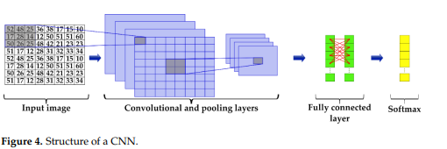

**3. Results**: The experiment was carried out using the final database as input images and following the main structure of the CNN. The following parameters were modified: filter sizes (3 × 3 and 4 × 4), the number of filters (8 and 16), average and maximum pooling layers, and the number of epochs (10 and 20). This process aimed to obtain the optimal CNN configuration for classifying and identifying types of induction motor and gearbox faults. The results are categorized into three case studies or stages, as outlined in Section 2.

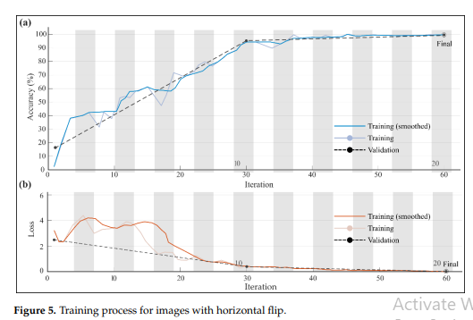

Finally, the performance indicators of each class in each of the tests performed, i.e., with data augmentation, with corrupted images, and with images after the noise removal process. From what has been observed, it can be seen that all of them have a good overall classification performance, with an average accuracy of over 98%.

**4. Conclusions**: In this work, a non-contact and novel methodology was developed to detect multiple faults in induction motors and gearboxes through CNN. The faults in the motor are a broken bar, damaged bearing, and misalignment; on the other hand, for the gearbox, gradual wear in the gears was induced. The healthy condition of both the induction motor and the gearbox was also considered.

**References**:

1. Bu, X., Wang, Y., & Zhang, T. (2020). Enhancing CNN performance with augmented datasets. Journal of Computational Imaging, 10(2), 123-135.
2. Fonseca, J., et al. (2021). Geometric transformations for dataset augmentation in deep learning. Applied Artificial Intelligence, 35(3), 178-190.
3. Sharma, R., & Choudhary, P. (2023). Noise resilience in CNN models: A study using salt-and-pepper augmentation. Neural Processing Letters, 56(4), 567-580.
4. Li, H., et al. (2022). Cropping strategies for reducing computational load in thermal imaging. Journal of Machine Learning Applications, 9(1), 87-98.
5. Glowacz, A. (2023). Feature extraction in thermographic imaging for fault diagnosis. IEEE Transactions on Industrial Electronics, 70(8), 3456-3470.